Using the Light Sensor

Scratch Version

April 23, 2017

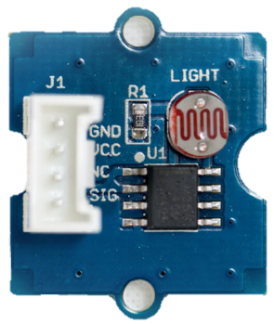

# Overview

The Light Sensor converts the amount of light shining on it into a number that your programs can use.

# Setting up

Power up your Raspberry Pi/GrovePi and start up Scratch. If you haven’t done this before, work through the “Getting started with Grove Sensors” document. Your screen should look like this:

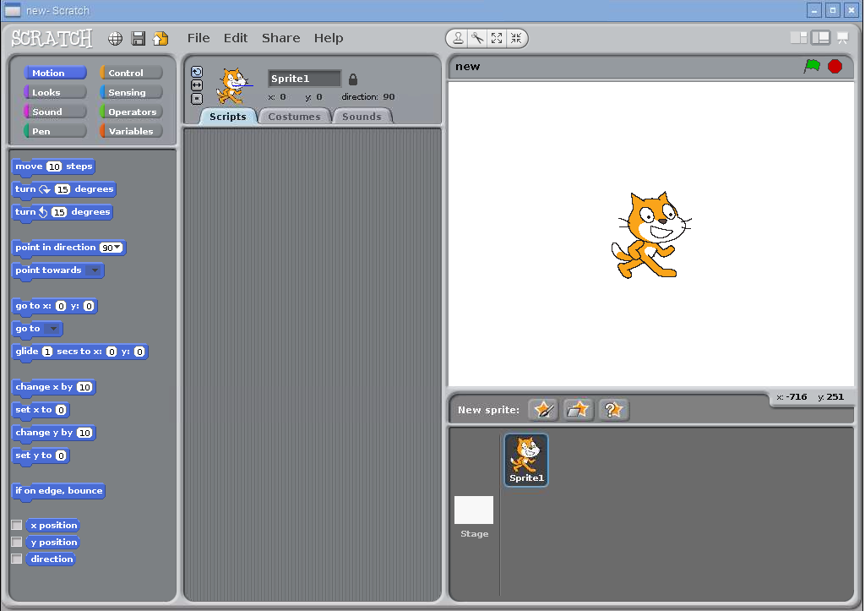

Now, find the Light Sensor and cable in the kit. Connect the light sensor to port A0. If you’d like to connect it to a different analog port, substitute the number 0 in the instructions below.

# Reading the light sensor

Like other Grove sensors, the light sensor only reports its value when it receives a broadcast. Try it out by placing a “broadcast” block:

Screen Clipping

Click on the black triangle to change the message and type in “light0” (change the zero to a different number if you’re using a different port):

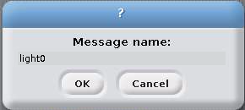

Click OK. Double click on the broadcast block so that Scratch knows that you’re interested in the light sensor on analog input 0 (Port A0).

The next step is to add a sensor block to your script that reads the button’s state. Go to “Sensing” and add the “slider sensor value” block at the bottom. Once you add it, you should be able to click on the black triangle to change what is being sensed. Here’s what you should see:

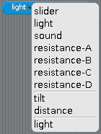

If you don’t see the second “light”, try double clicking on the broadcast block again and check that the light sensor is connected to Port A0.

Select either “light” in the menu so that your sensor value block looks like this:

Screen Clipping

Now it’s time to try out the light sensor. Build this script:

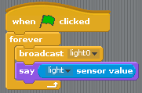

Run it and watch Scratch Cat tell you the amount of light hitting the sensor. The light sensor is what’s called an analog sensor. It reports values between 0 and 1023. See if you can get it to say 0 and 1023.